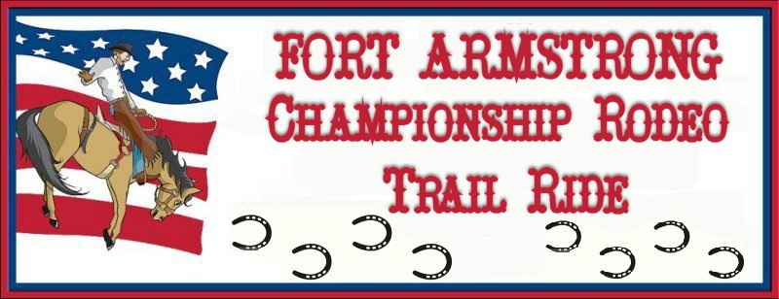

Date: July 8, 2017 Limited to first 100 horses
Place: Crooked Creek Horse Park, Ford City, PA

Sponsored by: The Guthrie Agency
217 First St. Apollo, PA (724)478-4381 - Please call for your insurance needs.
For Rodeo questions, use phone number listed below.

Cost: $40.00 per horse on the grounds
Arrival Time: AFTER 9am on Friday July 8th
Check-out Time: BEFORE 1pm on Sunday July 10th

Make checks payable to:
Fort Armstrong Rodeo
Mail registration to: Karen Clark
404 Eagle Lane
Apollo, PA 15613
Phone: 724-568-4448 Evenings for questions
Email: trailride@fortarmstrongrodeo.com

Includes:
* 1 wristband for admission to Friday & Sat. rodeo.
* Stall for 1 horse Fri. & Sat. – bedding not
provided.
* Participation in organized trail ride on Sat. 9:30am.
Ride will be approx 3 ½ hrs./Bag lunch provided
* Primitive Campsite - electric is additional –
fees will apply to sites setup in front of hookups.
* Sites will be limited to 20 ft width.
* www. fortarmstrongrodeo.com

 | Cost | Quantity | Total Due
1 Horse Package | $ 40.00
Electric Hookup with a Horse Package- includes Fri & Sat night | 30.00
Primitive Campsite-Fri & Sat- without a Horse Package- wristband add’l | 15.00
Campsite w/electric-Fri & Sat- without a Horse Package-wristband add’l | 45.00
Each additional day prior to 9AM Friday – Primitive camping | 5.00
Each additional day prior to 9AM Friday – with Electric Hookup | 15.00
Additional Adult admission wristband to Rodeo – includes Fri & Sat | 26.00
Additional Child (4yr-12 yr) admission wristband – includes Fri & Sat | 8.00

Children under 4yr are free

Total Due __________________

Name_________________________________________________Phone#__________________________

Address_______________________________________________________________________________

Email_________________________________________________________________________________
All riders will be required to sign a waiver.

Hold Harmless Agreement / Participant Release Waiver

On behalf of: Fort Armstrong Horseman’s Association / Foundation
Operator of Crooked Creek Horse Park, Manor Recreation Area, Ford City, PA

Event: Fort Armstrong Championship Rodeo Trail Ride

Date: July 7, 2017 through July 8, 2017

PLEASE READ CAREFULLY BEFORE SIGNING!!!

EVENT SPONSORS and CLUB ADMINISTRATORS DO NOT ASSURE YOUR SAFETY

I acknowledge that I, Participant, Parent or Legal Guardian, participate in this event totally at my own risk for injuries or property damage I or my family may incur and I acknowledge that I, Participant, Parent or Legal Guardian, et.al. hereby release and hold harmless the sponsor, co-sponsors, their owners, their officers, directors, members, affiliated organizations and others acting on its behalf, from any claim, legal liability, legal action, or right of damages, for any accident which may occur to me or my equine animal.

I, the undersigned Participant, Parent or Legal Guardian, being of legal age, have read and understand the above agreement and release.

___________________________ _____________________________ ________
Name of Participant * Signature of Participant Date
(Please Print)

___________________________ _____________________________ ________
Name of Parent/Guardian Signature of Parent/Guardian Date
(Please Print)

Address: _____________________________________
_____________________________________

Phone Number: _____________________________

* Please complete a separate form for each participant

