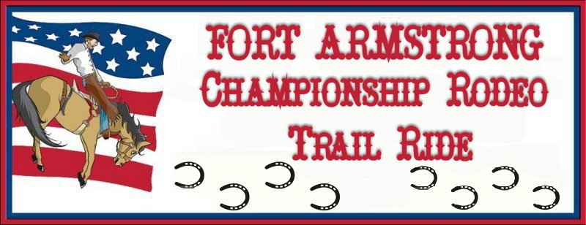

Date: July 13, 2019 Limited to first 100 horses
Place: Crooked Creek Horse Park, Ford City, PA
Sponsored by: The Guthrie Agency
217 First St. Apollo, PA (724)478-4381 - Please call for your insurance needs. Rodeo questions use number listed below.

Cost: $40.00 per horse on the grounds
Arrival Time: AFTER 9am on Friday July 12th
Check-out Time: BEFORE 1pm on Sunday July
14th

Make checks payable to:
FAHA Championship Rodeo
Mail registration to: Karen Clark
404 Eagle Lane
Apollo, PA 15613
Phone: 724-568-4448 Evenings for questions
Email: trailride@fortarmstrongrodeo.com

INCLUDES:
* 1 wristband for admission to Fri. & Sat.
rodeo
* Stall for 1 horse Fri. & Sat. –
Shavings WILL NOT be provided.
* Participation in organized trail ride on Sat 9:30
Ride will be approx 3 ½ hrs. Lunch provided
by Miller’s Hoagies following the ride
* All stalls will be locked until paid for
* Tack & Contestant stalls $25.00
* Primitive Campsite - electric is additional –
fees will apply to sites setup in front of hookups.
* Sites will be limited to 20 ft width.
* www. fortarmstrongrodeo.com

Cost Qty Total Due
Tack Stall / Contestant stall | 25.00
1 Horse Package | 40.00
Electric Hookup with a Horse Package- includes Fri & Sat night | 30.00
Primitive Campsite-Fri & Sat- without a Horse Package- wristband add’l | 15.00
Campsite w/electric-Fri & Sat- without a Horse Package-wristband add’l | 45.00
Each additional day prior to 9AM Friday – Primitive camping | 5.00
Each additional day prior to 9AM Friday – with Electric Hookup | 15.00
Additional Adult admission wristband to Rodeo – includes Fri & Sat | 26.00
Additional Child (4yr-12 yr) admission wristband – includes Fri & Sat | 8.00

Children under 4yr are free Total Due __________________

Name_________________________________________________Phone#__________________________

Address_______________________________________________________________________________

Email_________________________________________________________________________________
All riders will be required to sign a waiver.

Hold Harmless Agreement / Participant Release Waiver

On behalf of: Fort Armstrong Horseman’s Association / Foundation
Operator of Crooked Creek Horse Park, Manor Recreation Area, Ford City, PA

Event: Fort Armstrong Championship Rodeo Trail Ride

Date: July 12, 2019 through July 13, 2019

PLEASE READ CAREFULLY BEFORE SIGNING!!!

EVENT SPONSORS and CLUB ADMINISTRATORS DO NOT ASSURE YOUR SAFETY

I acknowledge that I, Participant, Parent or Legal Guardian, participate in this event totally at my own risk for injuries or property damage I or my family may incur and I acknowledge that I, Participant, Parent or Legal Guardian, et.al. Hereby release and hold harmless the sponsor, co-sponsors, their owners, their officers, directors, members, affiliated organizations and others acting on its behalf, from any claim, legal liability, legal action, or right of damages, for any accident which may occur to me or my equine animal.

I, the undersigned Participant, Parent or Legal Guardian, being of legal age, have read and understand the above agreement and release.

___________________________ _____________________________ ________
Name of Participant Signature of Participant Date
(Please Print)

___________________________ _____________________________ ________
Name of Parent/Guardian Signature of Parent/Guardian Date
(Please Print)

Address: _____________________________________
_____________________________________

Phone Number: _____________________________

* Please complete a separate form for each participant

